Management of clavicular non-union with double plate fixation and bone grafting:
Case Report

Aleksandrov Alyosha M.D.

Introduction:
Clavicle fractures are the most common type of fracture in children. They constitute approximately 50% of shoulder girdle fractures in adults.
(1) If displaced clavicle fractures are not operated, union does not occur, it also causes shoulder movement limitation and pain.
2) Nonunion of the clavicle after trauma is a rare condition.
It is a complication with a frequency of approximately 1% in adults.
(3) Surgical intervention is absolutely necessary after clavicle nonunion. Various techniques are available in the literature for this purpose.
E.g. coclavicular screws , intramedullary fixation with long pins and screws , open reduction and internal fixation with plates , external fixation , lag screws fixation and bone grafting. Sadiq S et al. showed that double plating provides more rigid fixation than single plating and is an alternative treatment in case of clavicle fractures and nonunion (4). We will try to present in this case report ,we achieved union by applying double plating in a patient who developed nonunion after clavicle surgery.
Case Report:
A 49-year-old male patient had a motorcycle accident 2 years ago and was diagnosed with a left clavicle shaft fracture in a different healthcare institution.
The patient was told that conservative treatment would be applied by applying a velpau bandage.
The patient was recommended surgical treatment in a different health institution and the clavicle was fixed with a plate and screw.
After 1 month, it was seen that there was plate screw failure(figure3 in the control, and plate screw removal was performed from the patient.
The patient was told that 6 months later, plate and screw would be applied again according to the condition of the bone.
The patient underwent surgery at a different center, about 3 months later, with plate screw fixation and grafting from the iliac wing.
After about 3 months, the patient goes to the control with sudden pain and noise from his clavicle while he is in the bathroom. After the control, it is seen that the plate is broken and surgery is recommended to the patient.
The old broken plate is removed and the patient is fixed with a plate and screw.
No union is seen in the x-ray images of the patient during the follow-up period of approximately 2 months.(Figure 1).
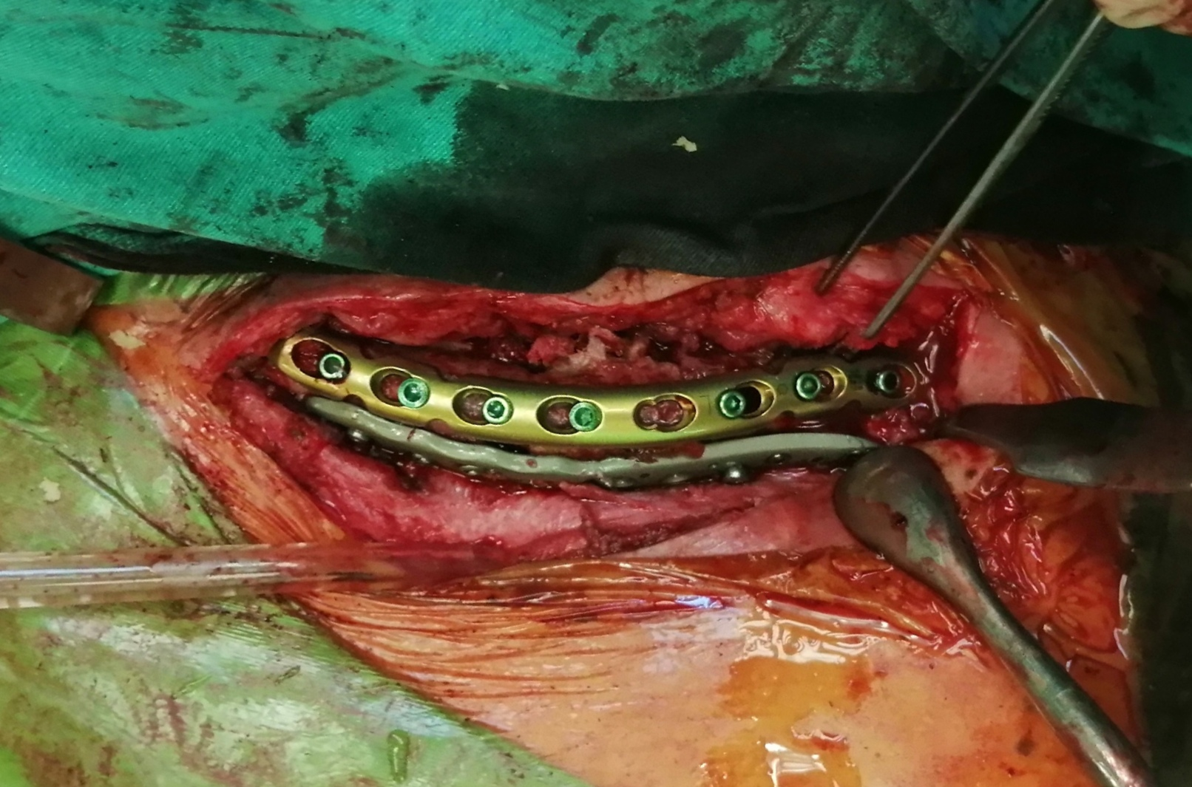
Fig.1 Double clavicula plate fixation and bone defect filling
The patient's 5th surgery is decided in a different center. Double plating is applied to the clavicle of the patient. After the follow-ups, it is examined with full union and full ROM patency.(Figure 2).
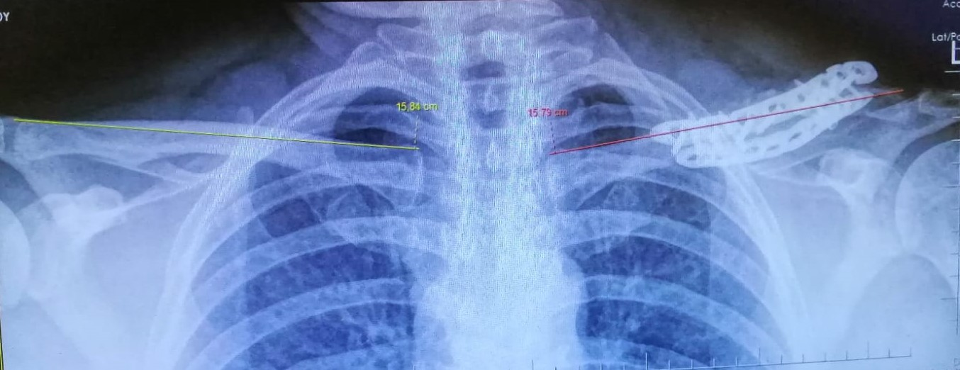
Fig.2 Fused and equal length clavicle bone
Discussion:
Clavicle fractures generally heal conservatively without the need for surgery, and nonunion can be seen in 0.9%-4% after conservative treatment.
(5) Absolute indications for the surgical treatment of clavicle fractures are open fractures, wide angulation at the fracture line, skin perforation, neurovascular damage, and displacement with a potential risk for symptomatic nonunion.
.(6) Nonunion can be seen in around 4.4% postoperatively.
Indications for the surgical treatment of clavicular nonunion,
pain due to nonunion, weakness and dysfunction in the shoulder girdle can be listed as neurovascular compromise.
(7)Various surgical techniques are described in clavicle nonunion surgery.
for example, coracoclavicular screws , intramedullary fixation with long pins and screws , open reduction and
internal fixation with plates , external fixation , lag screws fixation and bone grafting.
However, due to the complexity of the anatomical structure of the clavicle, sometimes a single fixation may not be sufficient in cases of nonunion. Therefore, double plating for rigid fixation is also used in complex situations in non-union surgery.
.(4) In this case, we provided complete union and full shoulder function with the double plating and grouting method described in the literature in order to provide a rigid fixation in the non-union clavicle fracture after various surgeries.

REFERENCES

- Rockwod C. A. Jr., Green D. P., Buchholz R. W., Heckman J. D. Fractures in Adults. WB Saunders. Philadelphia, vol. I., 1997, pp. 1109-1161.
- Neer C. S. II. Nonunion of the clavicle. JAMA, 1960, 172, 1006-1011
- Caterini R, Farsetti P, Barletta V. Post traumatic nonunion of the clavicle in a 7 year old girl. Arch Orthop Trauma Surg 1998; 117:475-476.
- Sadiq S, Waseem M, Peravalli B, Doyle J, Dunningham T, Muddu BN. Single or double plating for nonunion of the clavicle. Acta Orthop Belg. 2001 Oct;67(4):354-60. PMID: 11725567.
- Buchholz RW, Heckman JD. Fractures in Adults. 5th ed, Lippincott Williams & Wilkins, Philadelphia, 2001, pp 1041-1078.
- Curtis RJ. Operative management of children’s fractures of the shoulder region. Orthop Clin North Am. 1990;21:315-324.
- Khan MA, Vakati SR. Management of clavicular non-union with plate fi xation and bone grafting. Arch Int Surg 2013;3: 49-51.

Aleksandrov Alyosha MD
Bul.Dame Gruev B.C.Hipokrat 5/13 BURGAS 8001 BULGARIA
GSM +359882004923 e mail: alejandro63bs@gmail.com

